Deconsolidation Steps
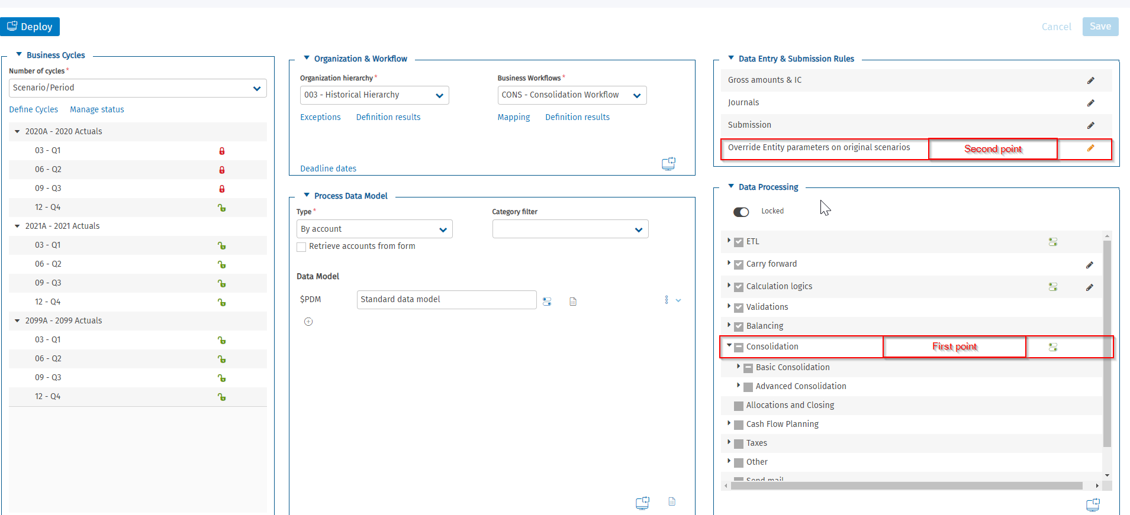

Consolidation Area in process
In the consolidation Area of the process, in the consolidation scenario an event must be created for the deconsolidated company. Different deconsolidation methods are available:
- From Entity elements table: the system uses the settings present on the entity dimension.
- Not to deconsolidate never runs deconsolidation.
- Deconsolidate only initial balances: for entities on which no FS data has been entered on the original scenario (except for carry forward), on the original scenario the system only deletes data originating from carry forward operations from the previous year. Used when the deconsolidated entity merges with another entity in the group or is sold at the start of the current year.
- Deconsolidate from previous period: data not yet consolidated is attributed to the subsequent consolidation period. Used when the entity is sold or merged during the year soon after the last interim consolidation.
- Deconsolidate from current period: data deconsolidation follows the standard process. Used when an entity for which significant data has been entered on the original scenario is sold or merged during the year.
This event has to be done for each consolidated scenario/period of the current year of deconsolidation, if we don’t add an end date in the entity.
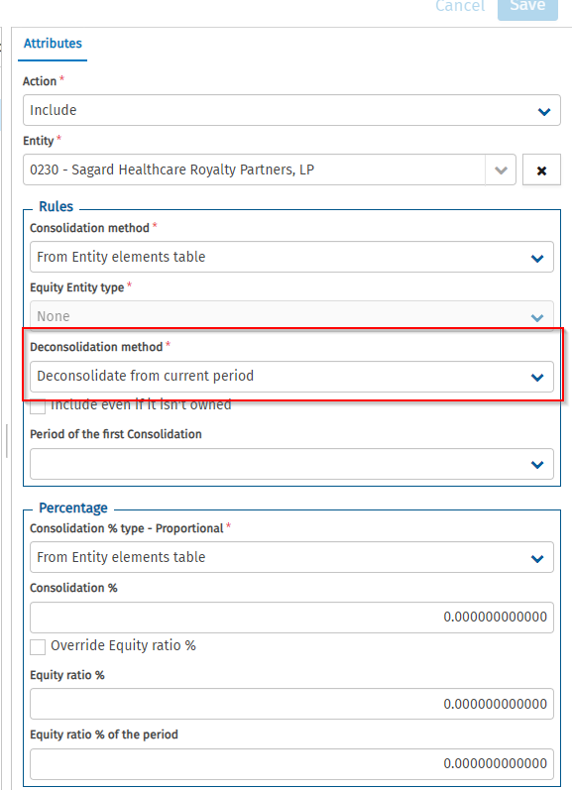

Override Entity parameters on original scenarios
In addition to the Consolidation area in which we have to exclude the entity (see previous step), it is also needed to create an event in the “override Entity parameters on original scenarios”. In this page, you can define overrides to entity attributes for the process’s original scenario/period.
The deconsolidated entity has to be selected together with the original scenario to which the process has to apply the deconsolidation. It is possible to either select one scenario/period or to either select all scenario/period.
Concerning the deconsolidation method, for the first period for which the deconsolidation is done, the method deconsolidate from current period has to be used. However, for the following periods, the method deconsolidates only initial balance can be used. Indeed, as no new data will be charged for this entity for the following period (n+1), the system will only deconsolidate the carry forward.
For the first period:
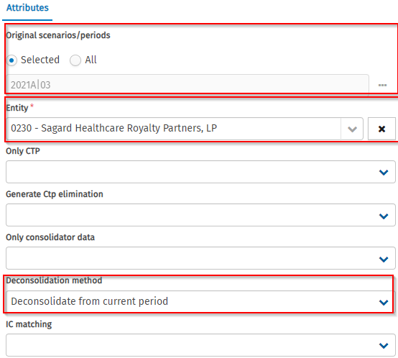

For the following periods
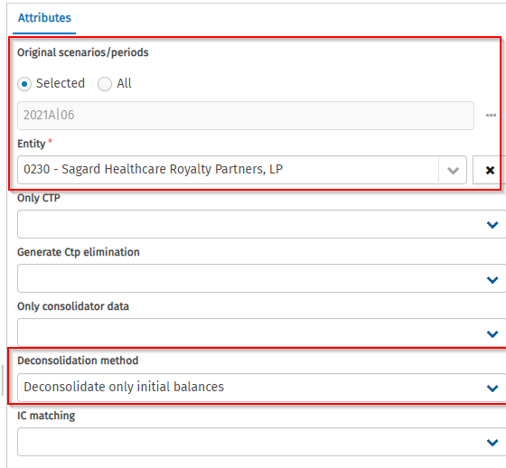

Create a deconsolidation event
In the Ownership structure, an event for the deconsolidation must be created. The event date is the date of the deconsolidation at which the entity has been deconsolidated. Then refer the deconsolidated entity.
For the event types, three types of deconsolidation event types exist:
- Deconsolidation - No Control - Full Goodwill: This event refers to a scenario where an entity sells its ownership stake in another entity, resulting in no control over that entity post-transaction. For accounting purposes, this transaction involves various steps such as elimination of financial investments (F.I.), adjustments of net equity, accounting for goodwill, calculating capital gain or loss, and adjustments to reserves carried forward. The end goal is to reset the journal related to this entity to zero, which essentially means removing all traces of its financial impact on the owner entity.
- Deconsolidation - With Control - Full Goodwill: This event happens when an entity sells its entire stake in another entity that it previously had control over. Similar to the first scenario, this process involves eliminating F.I., adjusting net equity, and accounting for goodwill. But in this case, due to loss of control, it also involves writing off Full Goodwill accounts and adjusting for consolidation differences. Again, the goal is to reset the journal to zero, eliminating the financial impact of the sold entity from the owner entity's accounts.
- Deconsolidation - No FG: This event occurs when a company sells its entire F.I. quota in a subsidiary. It involves similar journal entries as the partial disposal, but here, the entire F.I. and net equity values are written off, the Goodwill account is adjusted based on the new ownership percentage (which becomes zero), and the capital gain or loss is computed. The reserves carried forward on the source entity are also reassigned to the sold entity.

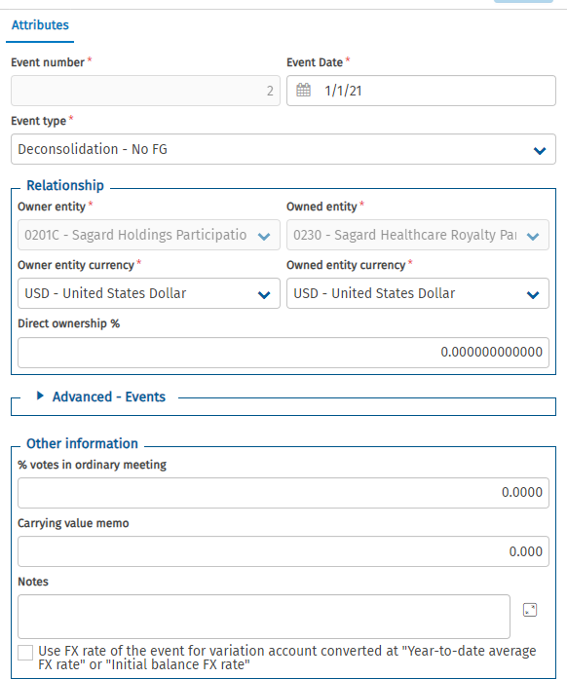

Make a consolidation and look if the account are well deconsolidated.

Look for the entity and corresponding scenario if the line is well deconsolidated. 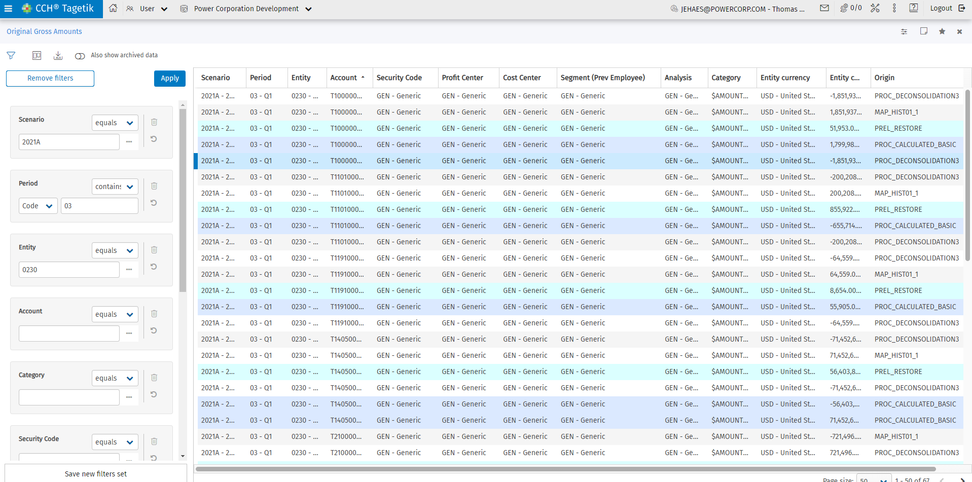

Entity End date
The end date affects the fact that we will no longer be able to upload data for subsequent periods. However, it is still possible to load data for periods ending on this end date.
By adding the end date, the entity will no longer be present in the processes for scenarios/periods after this end date, and users will therefore no longer be able to make any modifications for these.

The end date can be added in the Advanced section.


